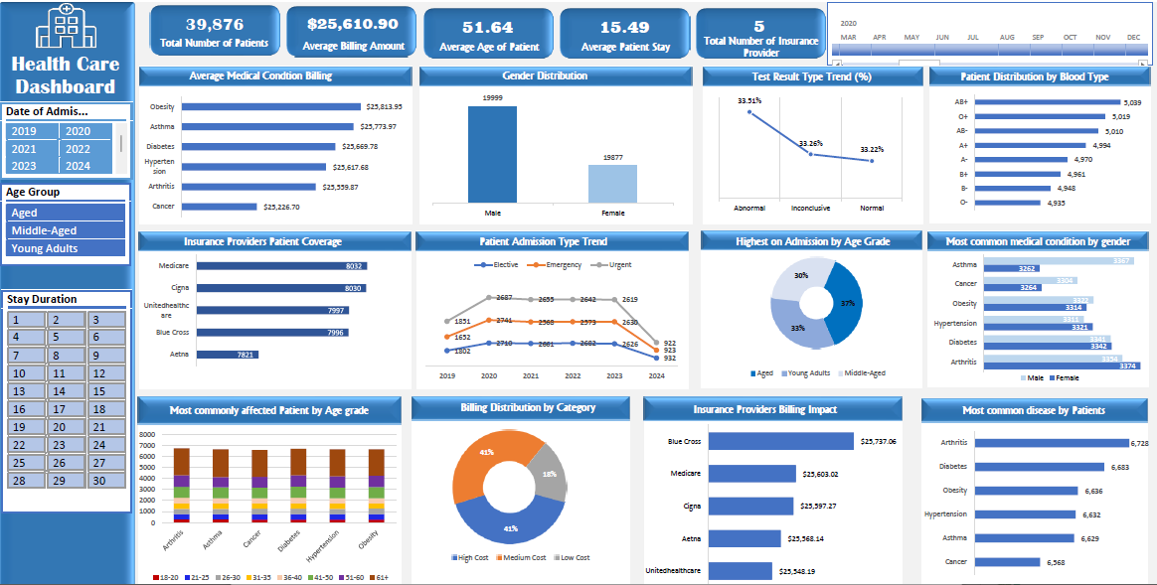

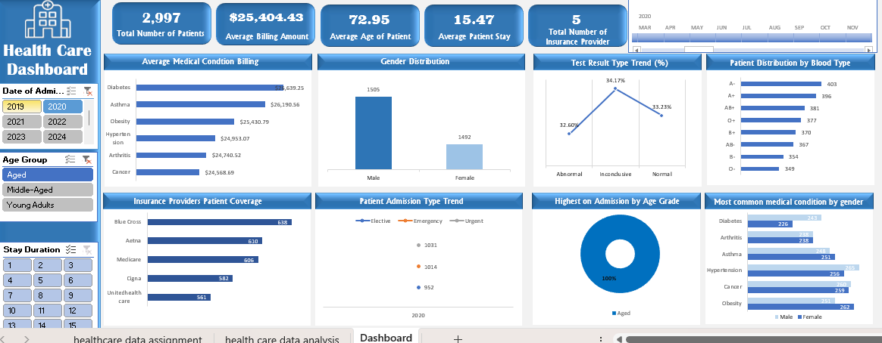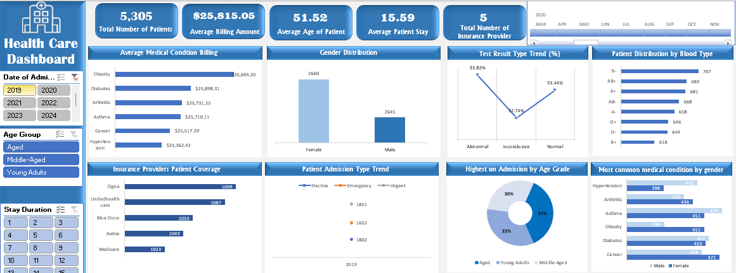

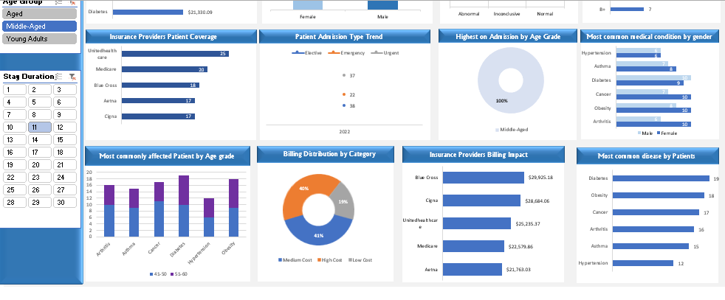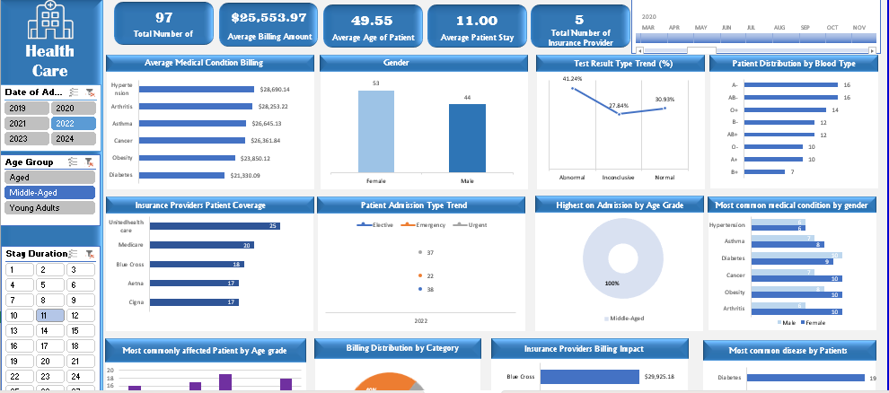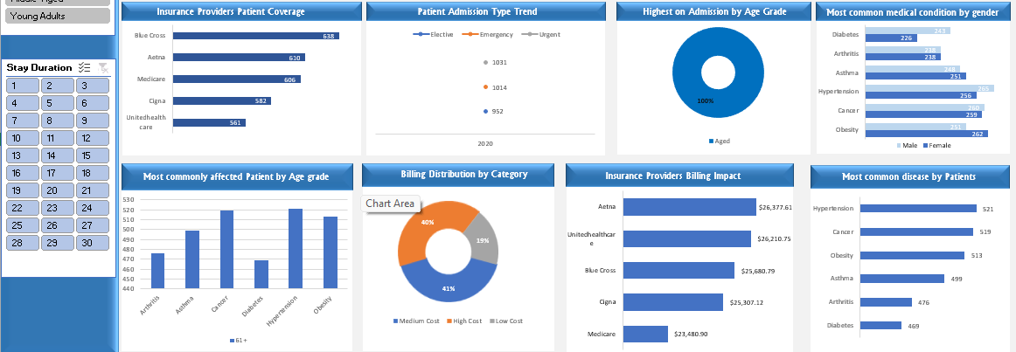

**MINI CAPESTONE PROJECT ON EXCEL**

**HEALTHCARE DATA ANALYSIS**

**AND**

**DASHBOARD REPORT**

**PREPARED BY**

**FRANCIS ESTHER**

**ABSTRACT**

This project presents a comprehensive dashboard built using healthcare data sourced from Kaggle and processed using Excel's Power Query, and analyzed using PivotTables and Pivot-Charts.

The objective is to explore and visualize patterns in patients admission, insurance coverage, billing categories, medications, and risk factors. Key metrics such as patient count, billing trends, disease distribution, and test outcomes are analyzed to provide actionable insights. Two data columns were removed due to significant inconsistencies during the data cleaning phase, standardization of categorical variables was carried out in order to maintain consistency in the data.

The final dashboard delivers a user-friendly interface with multi-level filters and visualizations that help healthcare providers/administrators, and Insurance providers make informed decisions.

**INTRODUCTION**

Healthcare institutions deals with massive amount of patient data. Hence effective analysis and visualization of these data plays an important role in understanding and improving patient care, cost optimization and resource management in order to enhance hospital efficiency in aspects of healthcare services.

This project focuses on building a dynamic healthcare Excel-based interactive dashboard to analyze multiple dimensions such as admission types, insurance providers, medical conditions, and demographic information. The dashboard aims to assist decision-makers by visualizing trends in medical conditions, patient age groups, insurance coverage, and cost distributions.

The goal is to identify patterns, trends, and critical insights that can aid decision-making.

**Data Collection Techniques:**

The dataset was sourced from Kaggle, a reputable platform for open datasets. It contains anonymized patient records with various healthcare parameters of 15 columns and 55,501 rows, ensuring privacy while providing rich insights into patient trends and medical conditions.

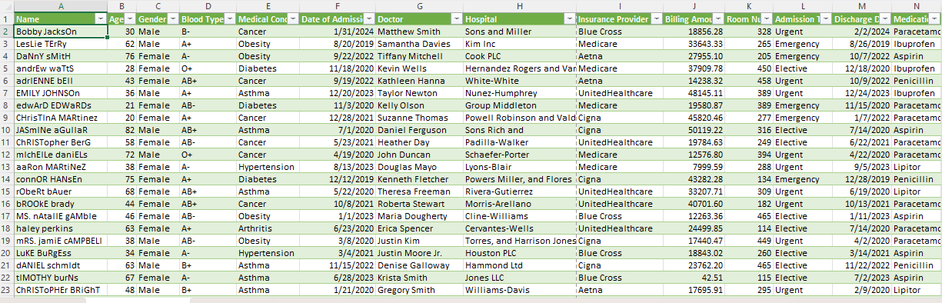

**Data Preparation Techniques**

To ensure the dataset was clean and suitable for analysis, the following steps were taken using Excel Power Query:

1. **Handling Missing Values**: Removed or imputed missing values in key columns such as discharge date and medical condition.
2. **Standardization:** Ensured uniform formats for date fields and categorical variables such as the Name column, Medical Condition etc.
3. **Creating New Variables**:
   * ***Stay Duration***: Calculated as the difference between discharge and admission dates.
   * ***Age Range & Age Group***: Categorized age into predefined ranges for better analysis.
   * ***Billing Category***: Grouped billing amounts into 'Low Cost,' 'Medium Cost,' and 'High Cost.'
4. **Removing Redundant Data**: Dropped the ‘Hospital’ and ‘Doctor’ columns due to Large rate of inconsistencies.
5. **Adding Risk Factor**: Patients were classified into risk levels (Low, Moderate, High) based on medical condition and test results.

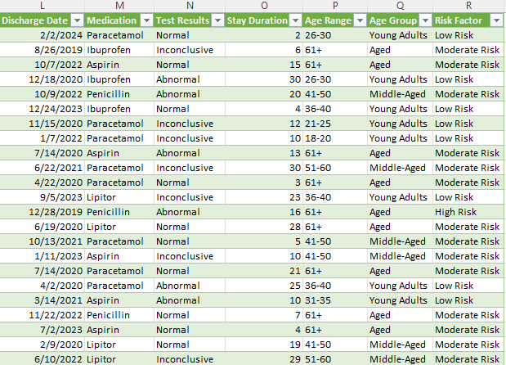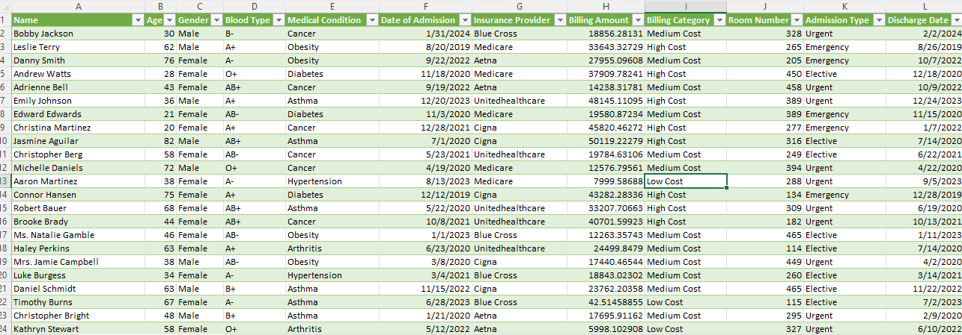

**DATA ANALYSIS FINDINGS:**

The following key insights were derived from the analysis:

1. **Patient Demographics**:
   * The majority of patients belong to the 51-60 and 61+ age groups.
   * The dataset has a fairly even distribution of male and female patients.
2. **Medical Condition Trends**:
   * *Most common medical conditions*: Arthritis, Diabetes, and Obesity.
   * *Age Group Most Affected*: The 61+ age group has the highest prevalence of chronic conditions.
3. **Hospital Stay Trends**:
   * The average stay duration is **15.49 days**.
   * Patients with Asthma and Arthritis tend to have longer hospital stays.
4. **Billing & Insurance Insights**:
   * The average billing amount for a patient is **$25,610.90**.
   * Patients covered by *Medicare* insurance has the highest number of patient. However, Blue Cross Insurance covers the highest total billing amount.
   * *High-cost billing* is associated with Elective and Emergency admissions.
5. **Test Results & Risk Factor Analysis**:
   * A significant percentage of patients had abnormal test results, indicating potential critical health issues.The **Abnormal test results** account for about **33.51%** of all tests.
   * High-risk patients are primarily within the **61+ age group**.

**Summary of Findings**

The analysis highlights significant trends in patient demographics, medical conditions, insurance coverage, and billing. Elderly patients (61+) are at the highest risk, with prevalent chronic conditions and longer hospital stays. Medicare is the leading insurance provider covering more patient counts while Blue Cross Insurance covers the high-cost treatments. The high percentage of abnormal test results suggests the need for preventive health measures.

However, the findings emphasize the importance of efficient hospital resource allocation and proactive patient management.

**Recommendations and Conclusion**

Based on the analysis, the following recommendations are proposed:

1. **Improving Preventive Healthcare**: Since chronic conditions dominate among elderly patients, hospitals should focus on preventive measures, early screening, and lifestyle interventions.
2. **Optimizing Resource Allocation**: Identifying high-risk patients early can help optimize bed occupancy and reduce elective and emergency admissions.
3. **Preventive Programs**: Develop age-targeted wellness plans, especially for the 61+ age group.
4. **Insurance Policy Collaboration**: Hospitals should work closely with major insurance providers to streamline better patient care coverage for long-term and high cost treatments.
5. **Enhancing Data Monitoring**: Hospitals should maintain and analyze similar datasets regularly to identify emerging trends and adjust strategies accordingly.
6. **Early Diagnosis and Treatment:** Given the percentage of abnormal test results, early intervention strategies should be enhanced.

In conclusion, the analysis provides critical insights that can guide decision-making in hospital management, insurance policies, and patient care strategies.

A well-structured healthcare analytics system can significantly improve patient outcomes and cost efficiency.

Future studies can incorporate machine learning techniques for predictive analytics to enhance patient care further.